Welcome to a new school year!!
Welcome to our 2nd grade classroom at Winner Elementary! My name is Miss Larson, and I will be your child’s teacher. As a 2nd grader, your child will become a more accomplished reader, writer, and mathematician. He/She will also gain more knowledge about the scientific world and his/her community. This letter contains important classroom policies and information for our classroom. Make sure you also visit and bookmark our classroom website: http://misslarsonsclass.weebly.com. It will be updated weekly.

Classroom Activities
- Each morning we will be involved in a whole class morning meeting that addresses various math and language concepts. During the morning meeting, we will work on calendar and weather activities, math skills, word of the day, interactive writing, and map skills.
- In math, we will utilize the Go Math! curriculum, South Dakota Counts/CGI (problem solving that requires more complex thinking and reasoning), and BUILD Stations (learning center activities that include Buddy Games, Using Manipulatives, Independent Work, Learning About Vocabulary, and Doing Math). Students will also be using the IXL Math website as part of our interventions program at Winner Elementary.
- Our Literacy Program (reading, phonics/spelling, and writing) will utilize the Treasures Reading Curriculum. We will also incorporate Guided Reading (reading based at the child's level), strategy lessons in a workshop format, and word work.
  - Guided Reading is reading that is level appropriate. Each student will be tested three times each year using the DRA, DIBELS, STAR Reading, and other literacy assessments. These assessments help check the student's reading progress and help determine what level of books the child should be reading. From these levels, students will be placed in a flexible group. These groups will be changed as needed for optimal leveled instruction. During guided reading instruction, groups will meet with the teacher to work on word attack skills, reading strategies, and comprehension. Students will also be required to complete various journaling activities as well as projects to go with each book.
  - Reading Workshop involves strategy lessons that emphasize mechanics of reading as well as comprehension. This time will also utilize independent reading and journaling activities. There will be teacher/student conferences to assess fluency and the use of these strategies. Reading workshop will also include Shared Reading and Read Alouds. Advanced picture books, big books, basal readers, poetry, and reader's theater will be used to model and practice the strategies taught in reading workshop. Shared reading and read alouds allow teacher modeling of critical thinking, vocabulary, print conventions, word patterns, reading with intonation/expression, and extending/responding to the reading.
  - Center Activities include Comprehension, Response to Text, Accuracy, Fluency, Teacher Table, and Study of Vocabulary. We refer to these center activities as CRAFTS. Students will have required activities that must be completed each week.
  - Word Work/Spelling involves working with letters and words in a purposeful way. During this time, word-attack strategies will be taught in a variety of formats. Students will complete daily assignments as well as a weekly Spelling Activity (Look/Cover/Write/Check, ABC Order, Picture Meaning, Word Sort, Word Transfer, and Word Use). Students will have a weekly spelling test that includes words following our studied spelling pattern and sight words (word wall words). Lists will be sent home each Monday and are also available at http://www.spellingcity.com/ml051.
  - Writing Workshop will utilize the Lucy Calkin's Units of Study for Primary Writers. This program includes a literacy-based curriculum that builds throughout the year. We will follow a workshop format that includes mini-lessons, interactive/ group writing, independent portfolio writing, and conferencing. Mini-lessons teach students writing strategies and writing craft. Mini-lesson topics range from brainstorming to editing/revision. Interactive writing is a time to "share the pen" and model effective writing techniques while during independent writing students will write on "real-life" topics and create a portfolio of writing. Finally, conferences can either be student/student or teacher/student. During this time, students will work on identifying areas of strength and also ways to improve their writing. Units of study will include Launching the Writing Workshop, Small Moments (personal narratives), Revision, Nonfiction Writings (How-To and All-About), and Poetry.
  - Our Science curriculum will focus on a combination of hands-on investigation activities and the study of Life, Earth, and Physical Science units. Our lessons will include exploratory mini-labs, class/individual reading assignments, journaling, and small-group/individual projects.
  - Our Social Studies curriculum will focus on neighborhoods and communities. Our lessons will include class/individual assignments, journaling, and small-group/individual projects.
Parent/Teacher Communication
I will send home weekly classroom updates each Thursday detailing our classroom activities. Please refer to these updates for topics we will be studying over the next week, upcoming tests, upcoming events, and other class information.
We will also have a Home Folder that will go home daily with important notes or parent signature sheets, daily homework, and other important information. Graded papers will be placed in the folder at the end of each week along with the weekly update. Graded assignments do not need to be returned to school. Please make sure that this folder is checked and returned every day. Lost folders will have to be replaced at the cost of the student.
In addition to our four report cards and parent/teacher conferences, I am always available to meet or speak with you. If it is not urgent, please jot a note (include it in the Home Folder) and I will respond as soon as possible. You may call the school and leave a message or e-mail me (michelle.larson@k12.sd.us) as well. In return, I will contact you by note or telephone if there is something that I'd like to discuss. I am also available to set up a meeting with you from 3:30 PM to 3:45 PM.
Homework and Homework Folders
I believe that homework is necessary for practicing skills that have been learned at school and for enriching the classroom experience. Our 2nd grade homework should take no more than 20 minutes and may include an at-home reading log, spelling practice, or math skill practice. Other times, I may send home an activity that is to be completed at home with parental guidance. This homework is a way to extend and enrich our skills to other activities and environments. I always will try to give ample time in class for the completion of most assignments; however, unfinished class work may also be sent home.

In order to help your child stay organized and get his/her homework returned on time, each student will take home his or her Home Folder each night. I encourage you to check your child's folder every evening. Please make sure that the work is completed and returned to school the next day in the Home Folder.

Behavior Policy, Classroom Rules, and Luck Bucks

Our classroom expectations are based on the Love and Logic philosophy as adopted by the Winner School District. The Love and Logic philosophy enables teachers and students to share control and decision-making while improving self-concept, behavior, and achievement for each student. It empowers students to learn from their mistakes and gain responsibility over their own choices.
Our classroom will also utilize an online behavior management tool called Class Dojo. With this program, students are awarded points for positive behaviors and may lose points for negative behaviors. Students will be able to track their points throughout the day by following their own avatar on the SmartBoard. Through Class Dojo, parents are also able to check-in on their child’s behavior with individualized online access codes.

In our classroom, students have the opportunity to earn Luck Bucks. Luck Bucks are classroom "money" that is earned by positive behaviors (as tracked on ClassDojo), returning forms and homework assignments on time, bringing back Home Folders daily, as well as many other ways. These Luck Bucks can be used to "purchase" items from the Luck Buck store every other month.
School Celebrations
We will hold school celebrations for Halloween, Christmas, and Valentine's Day. All parties will start around 2:30 PM and include treats and seasonal activities. Families will be assigned one holiday to help provide snacks (see Student Handbook or the wellness policy link for snacks that meet our school nutrition policy) or supplies. Please check your child’s folder for a holiday list in the near future.
- Halloween: Children may bring a costume to wear in the afternoon.
- Christmas: Students may bring a gift to exchange if they wish. Gifts should be under $3 and should be gender specific.
- Valentine's Day: A class list will be sent home in advance. If you wish to send Valentine’s cards, please include one for every student.
- Birthdays: Students that wish to bring birthday treats to share should try to choose items from the wellness policy. Please make sure to send all supplies needed to serve the treat as we do not have extra plates, cups, or serving tools at school.
There may also be other special school assemblies or celebrations throughout the year. Please check the weekly classroom update for more information.
Star of the Week/Share Bag
Students will have special assigned share days in which they may bring items to share with the class. I will send home a note alerting you of your child’s special day as the "Star Kid of the Week". I ask that no toys be brought to school from home unless it is your child's share day. Lost or broken toys result in very sad feelings! Children often keep some "treasures" in their backpacks - these, too, can get lost, so try to keep them at home.

Classroom Library
Our classroom is stocked with a leveled selection of books. Students will be checking out books from our classroom library for many purposes throughout the day. Students may also take home one book at a time. Please make sure that your child returns books the following day to school. If books are lost or damaged, you may be charged to replace the book and your child will not be allowed to take books home.
Box Tops, Soup Labels, and Grocery Receipt Collection
Our classroom will be taking part in the school-wide collection of Pop Tabs, Box Tops, LandOLakes Milk Lids, Campbell’s Soup Labels and Winner Food Center Grocery Receipts. Please make sure that Box Tops and Campbell's Labels are cut out neatly and completely intact. Please turn in all items for collection prior to the last school day of every month.
Dismissals and Absences
The school day generally runs from 8:00 AM to 3:30 PM. It is important that your child be on time as we begin our learning promptly at 8:00. Students should be dropped off at the multi-purpose room door. If a student needs to stay after 3:30 PM to complete work or make up time, I will send a note home or call one day in advance. If there are any changes in your child's after school transportation, please send a note or call the office. Planned Student Fridays and No School days are listed on the school calendar.
If you will be picking your child up early from school, please send a signed and dated note to school. This will ensure that there is adequate time to prepare work that your child will be missing. If your child will be absent, please try to call or send a note to school in advance; however, if that is not possible (due to emergencies or illness), please call the office or send a note explaining the absence. A note or phone call is required for an excused absence. Remember that classroom activities are an important aspect of your child's school day. Some activities cannot be made up at home; therefore, school attendance is highly important.

Thanks for helping to make this a great school year! If you have any questions about these policies, please feel free to contact me. Have a great school year!!

--Miss Michelle Larson

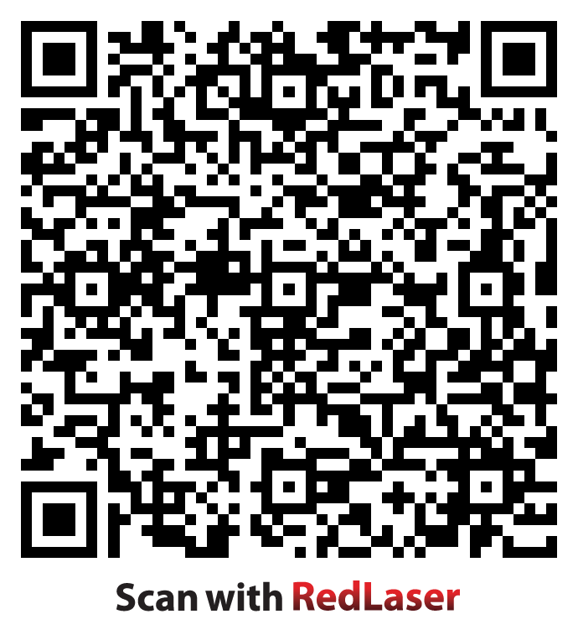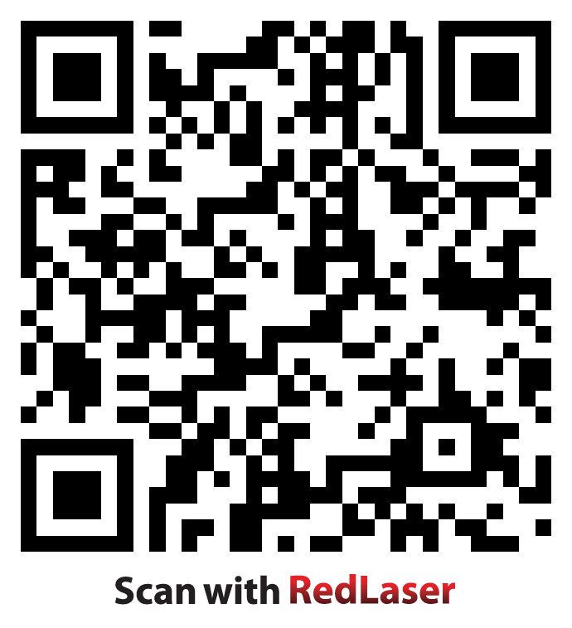

Scan this QR Code for a direct link Scan this QR Code for Miss
to updated weekly information, classroom Larson’s contact information.
pictures, and great links on our classroom website!

Miss Larson’s 2nd Grade
Classroom Rules and Expectations

Classroom Rules

- Follow Directions Quickly
- Raise Your Hand for Permission to Speak
- Raise Your Hand for Permission to Leave Your Seat
- Make Smart Choices
- Keep Your Dear Teacher Happy
-Based on the Whole-Brained Teaching Model

Classroom Expectations

- I will treat you with respect, so you will know how to treat me.
- Feel free to do anything that doesn’t cause a problem for anyone else.
- If you cause a problem, I will ask you to solve it.
- If you can’t solve the problem, or choose not to, I will do something.
- What I do, will depend on the special person, and the special situation.
- If you feel something is unfair, whisper to me, “I’m not sure that’s fair,” and we will talk.
-Based on Love and Logic: How I Run My Love and Logic Classroom-

